Speaking cards

PASSIVE VOICE







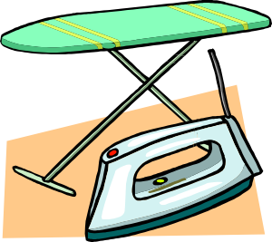





- Were many photos made by you last month?
- Are you often sent on business trips?
- Will new restaurants be built in your city?

- How many new words were learnt by you yesterday?
- Will any new things be bought by you next week?
- Were you given many presents as a child?

- Were you sent many messages yesterday?
- Will new trees be planted in your city?
- Are you often asked for help?

- Were you told an interesting story yesterday?
- Will many friends be invited for your next birthday?
- Have you been invited
to the party recently?

- Are you allowed to come home late
at night?
- Were your clothes ironed yesterday?
- Have you been prescribed any medicine recently?

- Was your cell phone bought last year?
- Will new schools be built in your city?
- Are your problems discussed with
your close friend?

- Was your English book bought by you?
- Have the dishes been washed today?
- Was your pet given food yesterday?

- Are your shoes made from leather?
- Was your breakfast cooked by you today?
- Will your apartment be
cleaned tomorrow?

